School of Medicine
University of Auckland

Clinical handbook

for
Otolaryngology

Mr Jim Bartley
Prof Randall Morton

2011 Revision by Miss Michelle Wong and Dr Jacqui Allen
2012 Revision by Dr Nick Lilic and Prof Richard Douglas

Department of

Otolaryngology - head and neck surgery,

CMDHB, ADHB, WDHB

Contents:

EAR

- History taking in patients with ear disease | page 3
- Clinical Examination | page 6
- Basic Audiometry | page 13

NOSE

- History taking in patients with nose disease | page 17
- Clinical examination | page 19

HEAD AND NECK

- History taking in patients with head and neck disease | page 21
- Clinical examination of the mouth and oropharynx | page 23
- Clinical examination of the neck and salivary glands | page 24
- Clinical examination of the larynx | page 27

QUIZ | page 28

Please also see http://www.flexiblelearning.auckland.ac.nz/orl
A. History Taking in Patients with Ear Disease

In much of medicine, but no more so than in Otolaryngology, the General Practitioner can and must obtain vital clues from an adequate clinical history, before examining the patient. Many relevant features of a good history are noted in the following sections.

The following symptoms referable to the ear should be recorded, taking note of their severity and their duration:

1. Hearing Loss
2. Ear discharge (Otorrhoea)
3. Pain (Otalgia)
4. Itching
5. Tinnitus
6. Vertigo

1. Hearing loss:
Hearing loss is the most common symptom of ear disease and is generally classified in one of two basic categories.
“Conductive hearing loss” is deafness caused by:
- occlusion of the external auditory meatus by wax or discharge
- a perforation of the tympanic membrane
- an effusion in the middle ear cavity
- or defects of the ossicles

A “sensorineural hearing loss” implies damage to the inner ear or nerve.

Regardless of the cause, the deafness may be of a degree so slight or more typically of an onset so gradual as to escape the patient's notice and someone else notices the deafness first. In fact usually by the time the patient perceives a problem, the hearing loss can be quite significant, so asking family or friends about the patient’s hearing is important.

Additional features in the history of hearing loss:
- Onset:
Sudden hearing loss may occur in a number of circumstances, for example following barotrauma (flying or diving), upper respiratory tract infection, exposure to excessive noise or blasts, drug administration (e.g. gentamicin) or head injury.

- Laterality:
Unilateral losses are more likely to have a specific cause (e.g. acoustic neuroma or vascular). Deafness due to age or noise exposure is bilateral and usually symmetrical.

Progress/Course:
Deafness due to age or continued noise exposure is often progressive. Meniere's disease and serous otitis media typically present with fluctuating hearing. An acute middle ear effusion after upper respiratory infection usually improves steadily.

Disability:
Generally patients with conductive loss manage well in group conversation or in a noisy environment. Patients with sensorineural hearing loss have poor speech discrimination in noise and usually hear better in one-to-one conversation.

- Special consideration- Children with reduced hearing:
It is critical to diagnose and treat children with hearing problems: childhood deafness can lead to dire behavioural, educational and social consequences. Hearing loss most commonly is a consequence of “glue ear”/OME. Remember to ask about a family history of deafness, problems associated with pregnancy or delivery and past history such as meningitis. Also enquire about behaviour and language development. Universal hearing screening is now available for newborns in New Zealand.

2. Discharge
- Discharge from the ear may arise from either the external canal or the middle ear cavity:
- The external ear usually produces a scanty discharge.
- Copious discharge generally indicates middle ear pathology. A foul smelly discharge may suggest cholesteatoma.
- A black discolouration in the discharge implies a fungal infection.
- Bloody discharge follows ear trauma, severe acute infection or tumour.
- Watery discharge may be CSF after a head injury (CSF otorrhoea).

3. Pain (Otalgia)
- The ear has a complex and varied sensory innervation receiving sensory branches from the cranial nerves V, VII, IX and X as well as branches from the upper cervical roots C2 and C3. Therefore, otalgia may arise from the auricle, the external meatus, the middle ear, and the mastoid or be referred from elsewhere.
- Take a good history of the pain including relieving and aggravating factors.
- In children, earache often indicates an inflammatory process in the middle ear, but may come from the jaw (teething) or pharynx.
- Adults complaining of otalgia and a normal otoscopic examination usually have a referred pain. Therefore think of a cause in the neck, nose, nasopharynx, pharynx, teeth, temporomandibular joint (TMJ) and larynx. Some pharyngeal cancers present only with otalgia and therefore a full head and neck examination is required.

4. Itching
Itching or irritation in the ear is most commonly associated with an otitis externa. However if the otoscopic findings are normal, consider TMJ dysfunction or bruxism (grinding of teeth).

5. Tinnitus
Tinnitus, the perception of noise in the ears or head, is common and difficult to relieve:
- The tinnitus may be constant or intermittent and usually vary in its intensity and character.
- It is more apparent in quiet surrounding and is aggravated by fatigue, anxiety and depression.
- It is not a disease, but a symptom and often regarded as an irritation to the cochlear mechanism or a centrally mediated sensation.
- Although tinnitus is a common symptom of hearing impairment, in certain conditions it is a useful clue. Such as in Meniere’s disease when the tinnitus is usually worse just prior to an attack, Acoustic Neuromas present as unilateral tinnitus or Glomus tumours presenting as pulsatile tinnitus.
- Do ask patients how the tinnitus affects their quality of life as some patients may be severely depressed by it.

6. Vertigo
Patients frequently use the general term “dizziness” to describe a wide variety of unpleasant or abnormal sensations, including vertigo. Taking an effective history, the doctor can determine whether the patient means vertigo or something else.
With vertigo, the patient experiences a hallucinatory sense of motion and typically uses words like “spinning” to describe it. For other causes of dizziness, the patient may instead choose words like “giddiness”, “unsteadiness” or “feeling faint” when asked to clarify what they mean.
The key point is that the presence of true vertigo indicates an abnormality in the balance system; conversely, the absence of vertigo excludes vestibular dysfunction and indicates the need to search for other causes including cardio-vascular, metabolic, haematological, and psychosomatic, etc.

The diagnosis of the cause of the vertigo or imbalance depends mostly on history. The particular areas to ask patients are:
- Onset:
If the symptom started following barotrauma (flying or diving), acoustic trauma or head injury, consider rupture of the inner ear membrane (perilymph fistula). If the symptom lasts a few seconds on adopting a sudden change of posture without any hearing loss, consider benign paroxysmal positional vertigo (BPPV). Acute fulminant vertigo in an otherwise healthy young adult is likely to be due to vestibular neuronitis.

- Duration:
- Vertigo lasts only a few seconds in BPPV
- For a few minutes to several hours in Meniere's disease
- For several days in vestibular neuronitis (and the patient can remain unsteady for several weeks)
- Persistent true vertigo lasting more than 3 weeks strongly suggests a CNS cause and warrants appropriate referral

- Associated symptoms:
- Aural symptoms such as hearing loss (fluctuating or progressive), tinnitus, earache, or discharge strongly suggests a labyrinthine cause
- Nausea and vomiting is typical of labyrinthine vertigo
- Central vertigo has associated neurological symptoms (e.g. dysarthria, visual disturbance) and not usually accompanied by auditory symptoms

B. Clinical Examination of the Ear

The following needs to be performed and noted for a complete ear examination:

- Examination and Otoscopy of the ear
- Examination of the facial nerve
2. Clinical tests of hearing
3. Clinical tests of balance

- Examination and Otoscopy:
The examination of the ear starts with the external ear. Examination behind the ear may indicate evidence of acute inflammation (swelling) or a scar from previous surgery.

Next examine the ear canal with an otoscope. Hold the otoscope gently like a pencil and choose the biggest speculum that will fit in the ear. Make sure the light source is as bright as possible. When you next look at an ear, change the intensity of the light source as the appearance of the tympanic membrane changes with brightness levels. In adults, traction on the pinna backwards and upwards and in children lateral traction helps to straighten the canal and facilitate vision. Rest the hand that holds the instrument on the patient's cheek to avoid injury to the external canal or tympanic membrane in case of sudden or inadvertent movement.

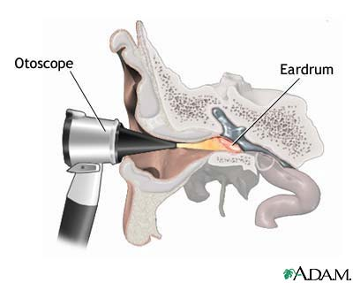 1.

Tympanic membrane:

If possible, the whole of the tympanic annulus should be examined as well as the handle and the lateral part of the malleus. Look for variations in the colour, contours and presence of fluid or fluid levels behind the drum. A prominent anterior wall often obscures the anterior part of the tympanic membrane. The attic region should be visualised. It is frequently useful to assess the mobility of the tympanic membrane by using the pneumatic bulb on the otoscope (pneumatic otoscopy).

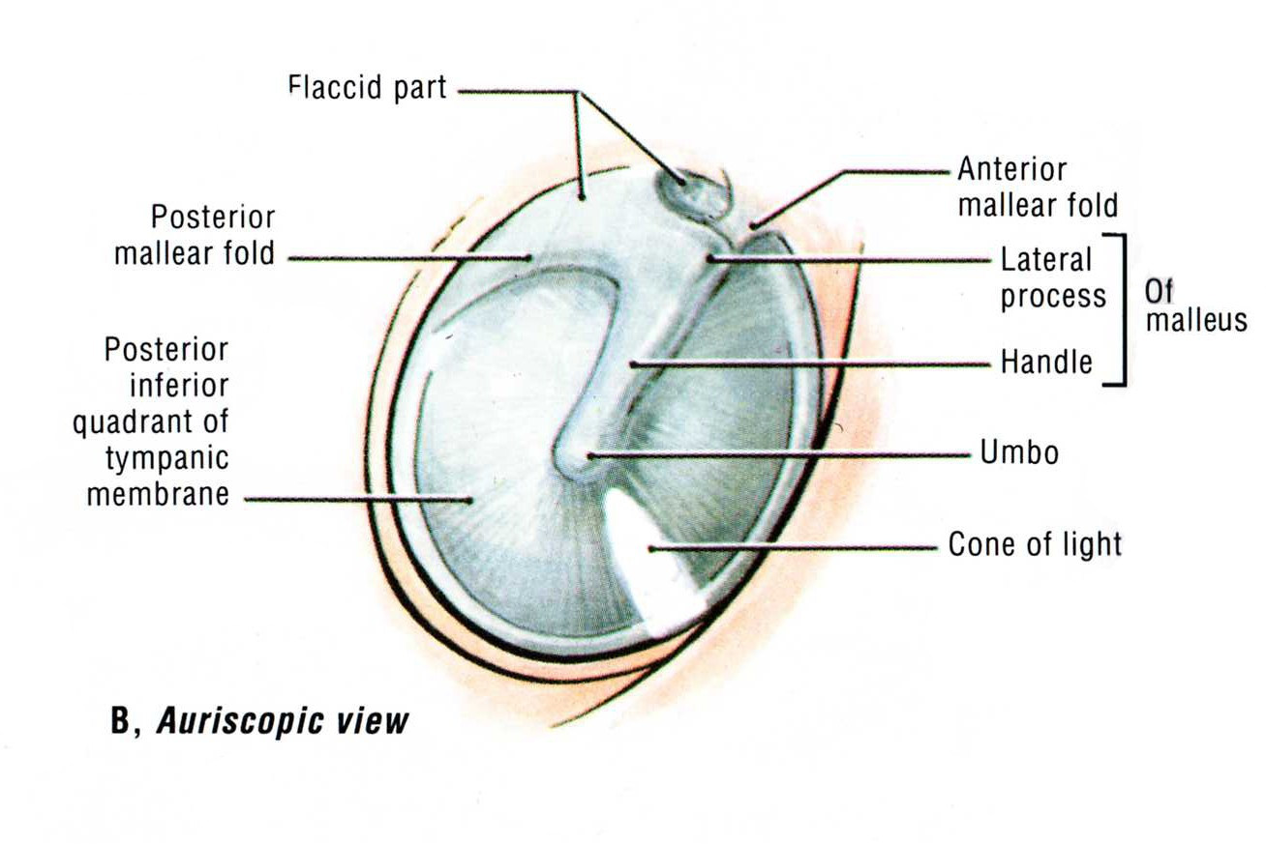

2.

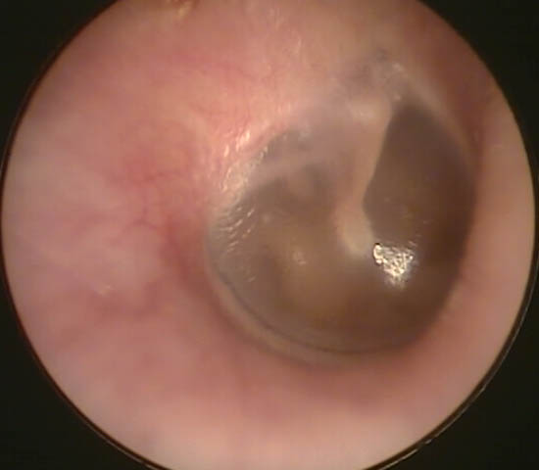

3.

- Examination of the Facial Nerve:
The facial nerve has a complex course in the temporal bone. From the brainstem it passes through both the middle ear (just above the stapes) and the mastoid cavity before exiting the stylomastoid foramen and branching within the parotid gland. Hence in complicated or advanced ear disease there may be ipsilateral facial nerve palsy.

For the below facial nerve divisions, note whether it is normal, slightly weak, very weak or no movement at all:

Testing: | Ask the patient to: | Pathology seen:
Frontal branch | Raise their eyebrows | Ipsilateral weakness
Zygomattic branch | Blink rapidly | Blink is slowed/ incomplete on the ipsilateral side
Buccal | Puff out cheeks | Unable to maintain the ipsilateral side when palpate cheeks
Marginal Mandibular | Show bottom teeth | Unable to depress the ipsilateral lip to show teeth.
Synkinesis | Pout repeatedly and quickly | Eyes will blink at the same time

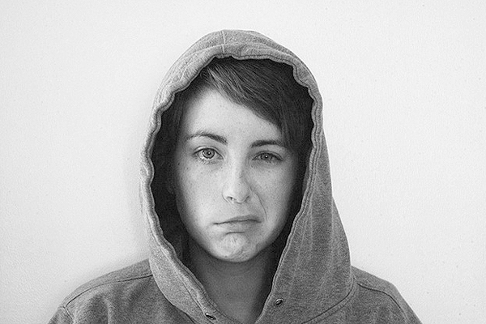 4.

- Clinical Test of Hearing:
During history taking the clinician should be assessing hearing. An estimate of hearing thresholds in each ear may be made by ‘masking’ the opposite ear by gently rubbing the orifice of the external auditory meatus with a finger and asking the patient to repeat what you say in the other ear. Whispering an arm’s length away from the ear is ~30 dB; next to the ear 50-60 dB

Tuning Fork Tests:

The right tuning forks to test hearing should have a frequency of either 256 Hz or 512 Hz (preferable). Higher frequencies decay too quickly for the Rinne test (see below) to be performed. A 128 Hz tuning fork may be detected by vibration alone. Tuning fork tests can be useful, but in unfamiliar hands their results can be unreliable.

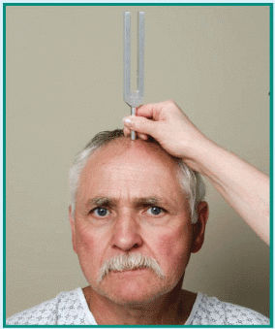
Weber test:
Gently strike the tuning fork against your elbow.
Place the base in the midline of the patient’s forehead and ask where the sound is heard.
- With normal hearing or in someone with an equal degree of hearing loss in each ear, the sound is not lateralised.
- In unilateral sensorineural deafness, it is referred to the good ear
- In a patient with a conductive deafness the sound lateralises to the affected (deaf) ear. Try this by placing the tuning fork in the middle of your head and then put a finger in your ear to mimic a conductive hearing loss.

5.

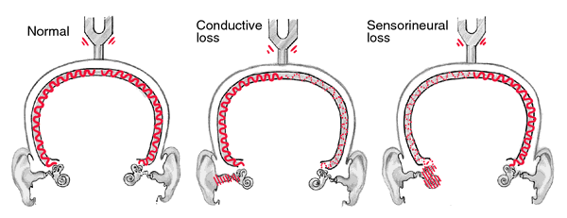6.

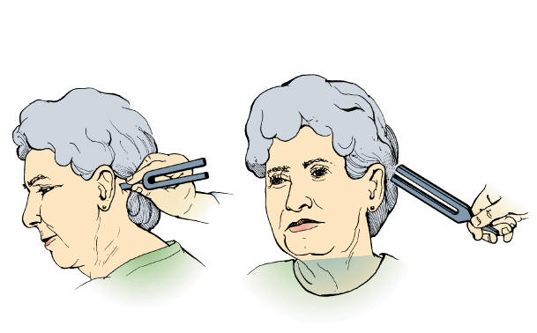
The Rinne Test:
Strike, then place the fork firmly on the patient’s mastoid (on bone and not on sternomastoid muscle) and use your other hand to steady the head.
Ask the patient to compare the sound intensity on the mastoid process (bone conduction) with that by the meatus (air conduction).
A “positive” Rinne test occurs if air conduction is better than bone conduction.
7.
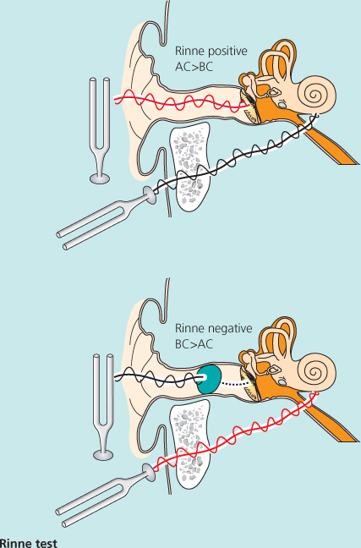 8.

With significant sensorineural deafness, a patient will only hear the air conduction and not hear bone conduction at all.

On the other hand, if the patient suffers from a conductive deafness of greater than 20 dB, he/she usually notes bone conduction exceeds air conduction, giving a “negative” Rinne test result.

False negative Rinne: With no hearing in the test ear, the patient may still perceive the bone stimulus in the opposite (non-test) ear. This mistaken impression of function in a non-functioning ear is called a “false negative” Rinne. One can check the diagnosis by masking the nontest ear (see the audiology section below). If the patient can still hear the sound with masking the other ear it is a true negative Rinne.

- Clinical Test of Balance:
Normal balance and body position is a complex function of neural input into the cerebellum and brainstem from:

- Eyes: (e.g. watching Imax movie can make you feel you’re falling)
- Proprioception: (e.g. Missing a step makes you feel like you’re falling a long way)
- Balance organ of the ears: stimulating the semi-circular canals such as a putting ice cold water in the ear will make you experience vertigo - basis of the Caloric testing.

Therefore, each component of the system needs individual assessment.

If hypofunction of one input occurs, then compensation by another usually occurs. However when such compensation is removed, for example by closing the eyes, the resultant deficiency may become manifest.

Nystagmus:
Ask a patient to follow your finger. Watch carefully for movements of nystagmus. Nystagmus is described by the direction of the fast phase, however because of the complex nature of nystagmus, it is better to describe it as:
    - When the nystagmus occurs (during left, right or central gaze)
    - The fast phase/ beating direction
    - Whether it’s horizontal or torsional

Head thrust/ Halmagyi Test:
The basis of this test is the Vestibular-Ocular-Reflex. Try it now! Hold these notes and move it side to side while trying to read it. Impossible? Now try holding the notes steady and moving your head side to side while reading the notes! This reflex enables us to react to changes of our head position without taking our eye off an object.

- For this test, ensure that your patient is not elderly or have neck problems. Tilt the patient head down 30 degrees from the horizontal.
- With hands and either side of their head, warn the patient that you’ll be moving their head for them and for them to keep their eyes on your nose.
- Quickly turn the patient’s head away from the midline approximately 15 degrees.
- Watch their eyes – the normal is that they are able to keep their eyes on your nose. However if the patient has a hypo-functioning vestibular system, when you turn their head to the side of the lesion their reflex is not intact, and your will see a corrective saccade.
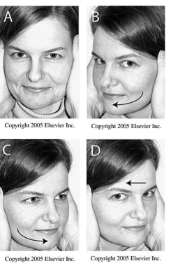
C and D suggest left vestibular hypofunction with a corrective saccade
A and B are normal

Romberg tests:
The patient stands erect looking forwards with the feet together. If the patient is stable, he/she closes their eyes. With a labyrinthine lesion the patient will often sway to the side of the lesion, a feature that is accentuated by closing the eyes. A central lesion in the cerebellum results in symmetrical swaying that is less affected by eye closure. The examiner can make the Romberg test progressively more difficult by next asking the patient to fold their arms across the chest and close their eyes and by thirdly having the patient try to stand with one foot in front of the other with eyes closed.

The gait test:
The patient walks in a straight line between two points and then quickly turns (spins) to return on a straight line. Patients with labyrinthine lesions deviate to the side of the lesion whereas marked imbalance on turning indicates a cerebellar lesion. Other tests include heel-toe gait, with eyes open and closed; >2 side steps is abnormal and suggests vestibular dysfunction.

The stepping or marching test (Fukuda or Unterberger):
A similar test to the gait test assesses the ability of the patient to repeatedly step or march on one spot with the eyes closed. A patient with vestibular dysfunction will gradually pivot toward the side with the lesion, usually within 30 seconds of marching.
(Think of a two-engine airplane flying in a storm. If the right engine goes off, without any visual input the plane will veer to the right from the thrust of the left engine)

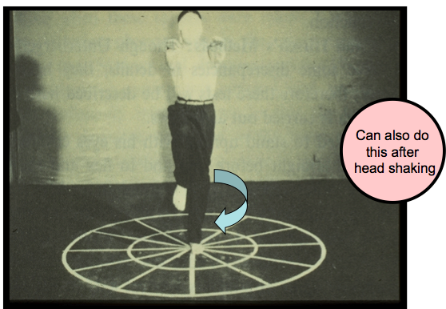

C. Basic Audiometry

Pure-Tone Audiometry:

Pure-tone audiometry is the most common test of hearing. It is performed best in a soundproof booth. The patient wears headphones or inserts through which pure tones are presented to each ear in turn. The patient is asked to respond to sounds of decreasing intensity across the frequency range. Both air conduction and bone conduction can be tested. Bone conduction is a measure of cochlear function.

Testing an individual ear can be difficult because the pure tone can be picked up by the non-test ear if it’s loud enough. To overcome this, the non-test ear is presented with white noise, this is called masking

Below are example audiograms of the right ear. In these audiograms the blue crosses represents bone conduction, the red circles represents air conduction.

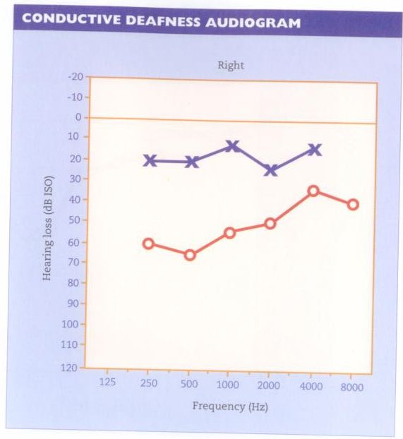
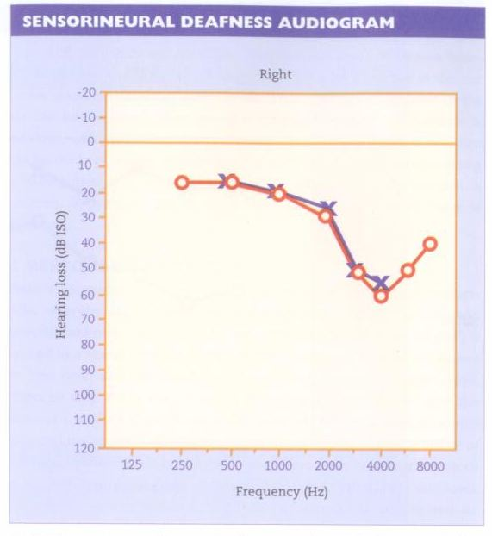
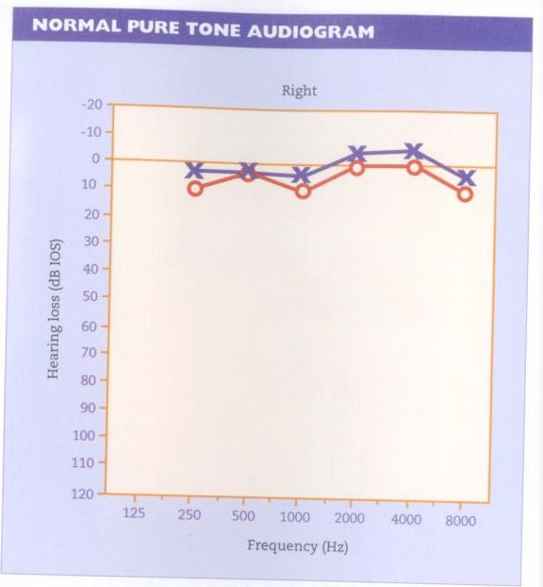

9.

Speech Audiometry:
In this test the patient is presented with phonetically balanced words and is scored on the number of correct responses

Tympanometry:
Tympanometry, a technique used extensively in clinical practice, is based on the fact that pressure in the external ear can be raised or lowered, thus stiffening the eardrum. A tympanometer presents a low frequency sound to the ear and measures the sound energy reflected from the eardrum. The eardrum is most floppy when the pressure on both sides of it is equal. If fluid is present in the middle ear or there is a perforation, the eardrum is unresponsive to changes in pressure of the external ear canal and a flat tracing is observed.

Tympanometry does not depend on major patient co-operation, so the test is quite useful in testing children for “glue ear” (otitis media with effusion).
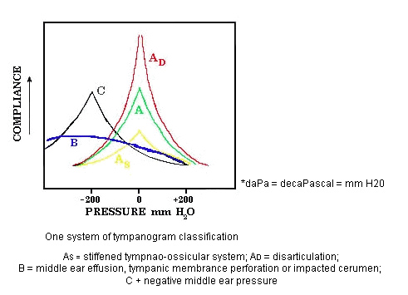
10

A. History Taking in Patients with Nasal Disease

Nasal symptoms are few, but have a wide range of possible causes. Therefore effective a history requires elucidation of those symptoms; including degree, duration and laterality, as well as any associated systemic upset or aggravating factors.

The following symptoms needs to be asked in the presence of nasal disease:

1. Nasal Obstruction
2. Increased nasal secretions
3. Epistaxis
4. Sneezing and itching
5. Snoring and sleep disturbance
6. Local and regional pain
7. Deformity
8. Disturbances of olfaction

- Nasal Obstruction:
Generalised swelling of the mucosal lining due to infection, allergy, polyps, crusting and vasomotor changes may cause bilateral nasal obstruction although patients may also note alternating obstruction with vasomotor rhinitis. Deviation of the septum (common) or a benign or malignant neoplasm (uncommon) may cause unilateral nasal obstruction; an S-shaped septal deviation can create bilateral obstruction.

Establish whether unilateral symptoms are totally unilateral, or bilateral but more prominent on one side.

A patient suffering from an allergy may have repeated short episodes of fairly acute symptoms and may notice the precipitating effect of a particular allergen or seasonality.

In children adenoid enlargement is a common cause of nasal obstruction and usually presents as persistent mouth breathing that is worse in the supine position e.g. causing snoring and symptoms of OSA at night time.

2. Increased Nasal Secretion:
The nasal mucosal glands and goblet cells produce a constant thin film of mucus which covers and protects the underlying respiratory mucosa. If the consistency of the secretion changes, or if its slow but steady movement towards the nasopharynx is interrupted, stasis occurs and the patient then often notes the presence of thicker mucus in the pharynx, often referred to as “post-nasal discharge”. Irritation of the mucosa by infection or allergy - or by increased parasympathetic outflow - will lead to increased secretions. Excessive thin secretions run anteriorly and give rise to rhinorrhoea.

Watery rhinorrhoea is usually a symptom of viral infection, allergic rhinitis, or vasomotor rhinitis. Usually, infective nasal conditions also give rise to general malaise and raised temperature. While either bacterial or viral infections can produce purulent secretions, thick mucus, especially if purulent, more often suggests chronic rhinosinusitis.

Beware persistent unilateral discharge. Unilateral nasal discharge in a child is usually caused by a foreign body. Adults with unilateral blood-stained discharge may have a tumour.

3. Bleeding (Epistaxis):
Epistaxis occurs at some stage in about 10% of the population. Acute inflammation, trauma and bleeding disorders are common causes. The most common site is the anterior nasal septum (Little’s area). After 40 yrs, bleeding from the posterior part of the nasal cavity is more prevalent and more hazardous; hospital admission may be required.

4. Sneezing and itching:
Sneezing is the normal nasal reflex to clear secretion from the nose. Irritation within the nose, infection or allergy, or inhalation of noxious gases or polluted air are common stimuli. Irritation within the nose also causes itch and is a common feature in allergy. In allergic rhinitis the eyes and soft palate as well as the nose may also be affected. Do ask if they have associated atopic diseases such as asthma, dermatitis, eczema or hay fever. Also remember to ask if they have been on any medications that were either successful or not.

5. Snoring and Sleep Disturbance:
One can best conduct the history of these frequently related complaints with the bed partner in attendance. Key questions include whether snoring occurs every night in every position, whether there are periods of apnoea and what is the quantity and quality of sleep. The patient or bed partner also may volunteer being a restless sleeper and "waking tired". Remember to ask about inappropriate daytime somnolence.

6. Local and regional pain:
Facial pain can be a multifaceted problem. As always, a history of the pain: (type, periodicity, site, relieving and aggravating factors) helps to identify possible causes. Note that headaches associated with sinus disease can be localised over the sinus or present in the vertex (sphenoid sinus disease) or referred to the teeth in maxillary sinusitis. Chronic sinusitis is generally not associated with headache but rather with pressure symptoms.

7. Deformity:
As the nose is a dominant facial feature, its appearance is important to most people. Moreover, a deformed exterior may often reflect internal functional problems. Swelling in the cheek may represent a tumour in the maxillary sinus, and should be referred.

8. Disturbances of Olfaction (Sense of Smell):
Hyposmia is the term used to describe a reduction of the sense of smell. It occurs in many nasal diseases, when the air stream is unable to reach the olfactory area, such as in infection, allergic polyp disease and tumours. Anosmia (the complete loss of sense of smell) or Phantosmia (phantom smells) can follow head injuries or viral infections.

B. Clinical Examination of the Nose and Sinus

The following needs to be performed and noted for a complete nasal examination:

- Examination of the external nose
- Examination of local and associated structures
3. Examination of the internal nose

- Examination of the external nose:
Examine the external nose by observation and palpation; the nasal bones only occupy the superior one-third of the external nose with cartilage the remaining portion. When assessing injury to the nasal bones and cartilage, remember to look for injuries to adjacent structures, particularly the eye and it’s movement.

- Examination of local and associated structures:
Tenderness to percussion over the maxillary and frontal sinuses often indicates sinus disease.

Don’t forget to look inside the mouth at the palate. A tumour can cause a fistula. Also look at the oropharynx for the presence of blood or a polyp – an antrochoanal polyp can extend down past the uvula or a patient may have on-going posterior epistaxis – obvious with blood dripping down in the oropharynx.

- Examination of the internal nose:
Examination of the interior of the nose needs good lighting, appropriate instruments and occasionally the topical use of a vasoconstrictor to shrink the nasal mucosa. A headlight is necessary for a thorough examination and leaves both hands free for using instruments. In children, where use of instruments is best avoided, simple upward pressure on the tip of the nose allows a surprisingly full examination of the vestibule and beyond. Similarly, upward pressure on the nasal tip in adults will demonstrate a dislocated (and therefore disturbed) septum. Using a hand-held otoscope with a wide speculum is helpful.

When examining the internal nose these are helpful things to remember:
- Airway patency: hold a metal tongue depressor under the nostrils and ask the patient to breath out of their nose. Both sides should fog over equally to indicate nasal airway patency.
- Septum: look at the septum for deflections, at Little’s area for obvious blood vessels, and if there had been a recent trauma ensure that there is no septal hematoma. If you’re not sure if it’s a hematoma or deflection then gently use a probe to palpate the septum
- Inferior turbinate: Using a speculum look at the inferior turbinates and see the size and overlying mucosa. Also look for evidence of polyps, which would appear white, or any mass that fills the nasal cavity.
- Nasoendoscopy: In this examination the nasal cavity and posterior nasal space can be seen clearly.

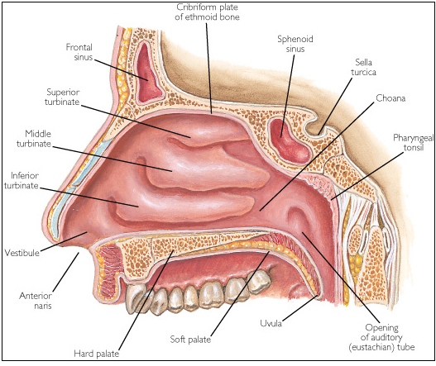11
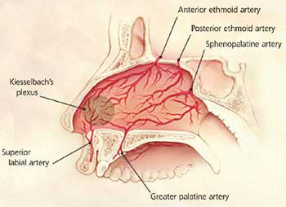

12.

A. History Taking in Patients with Head and Neck Disease

With problems of the upper aerodigestive tract and neck consider: is it congenital or acquired? If acquired, is it infection, inflammation, trauma, endocrine or tumour?

Patients may present with a mass in the neck or a lesion in the mouth, but more frequently they come with one or more of the following:

1. Pain
2. Discomfort / Globus
3. Dysphagia
4. Stridor
5. Hoarseness
6. Mass or lump in the neck
7. Weight and weight loss
8. Social factors

1. Pain:
Obtain a description and site of the pain, with relieving and aggravating factors. An acute sore throat is usually acute and associated with viral or bacterial infections, whereas chronic oral pain be very suspicious of malignancy. A tumour of the base of tongue, larynx, and oro-/laryngo-pharyx is often associated with referred unilateral otalgia.

2. Discomfort / Globus:
Many patients complain of discomfort or a painless “lump” in the throat. Ask the patient to point specifically to where the sensation is felt. Always ask a crucial supplementary question: does solid food actually stick? If yes, the patient is describing dysphagia as outlined below; if no and the discomfort is actually relieved when eating, it is more likely to be globus. While we recognise that globus is often related to stress, it is not necessarily psychosomatic in origin – GORD is a common cause.

3. Dysphagia:
This may vary from occasional ‘catching’, to an inability to swallow solid food. Patients with pharyngeal pouch commonly regurgitate old food. Nasal regurgitation of food, or aspiration of liquids, suggests an underlying neurological problem. Patients with tumours often describe a gradual decline in their ability to swallow food and history of weight loss should ring alarm bells.

4. Stridor:
Obstruction leads to diminished airflow, turbulence and a musical noise called stridor. This is usually inspiratory stridor when the blockage is at or above the level of the vocal cords. (Expiratory stridor typically originates from the bronchi and bronchioles and is termed wheeze). In children, the area below the vocal cords - the subglottis - is the narrowest part of the airway and, when pathologically narrow, causes biphasic stridor.

5. Hoarseness:
This is a symptom of primary laryngeal disease although occasionally it may be a manifestation of distant disease such as hypothyroidism or lung cancer. It can be described as a “breathy” voice. A patient with hoarseness lasting more than three weeks needs a referral to an Otolaryngologist.

6. Mass or Lump in the Neck:
Children can have impressively enlarged lymph glands secondary to upper respiratory infections, either bacterial or viral. However, a mass or palpable lump in the neck in an adult is malignant until proved otherwise and needs an otolaryngological review. A patient should be asked about the site, duration and progress of the mass. Further questioning will depend on the site of the mass. Always ask about associated symptoms such as hoarseness or dysphagia. In patients with a suspected secondary node in the neck, remember to ask questions relating to a possible primary site - e.g. nasopharynx in people of Chinese descent.

7. Weight and Weight loss:
Because head and neck tumours often affect swallowing, a history of weight loss should be regard with an index of high suspicion. Secondly, treatments to the head and neck region, particularly radiotherapy, will often cause at least some degree of dysphagia. So do record the initial weight of the patient and an impression of nutritional status.

8. Social factors:
A social history is important in all areas of ENT, however in the head and neck patient this is vital as it does impact on the treatment the patient may get.
- Smoking and ETOH: A smoking history is important as it is a strong aetiological factor in head and neck cancer. A lack of smoking is also important too, because patients with non-smoking related oropharyngeal cancers (HPV-related) have a much better prognosis.
- Occupation: Treatment of head and neck cancers can be physically and functionally morbid. Do ask about occupational history; an actor whose livelihood is dependent on his voice, may choose to have radiotherapy instead of surgery for early larynx cancer for the better voice preservation rate.
- Social support: Again this may strongly influence treatment options and discharge planning. Patients with strong social support may be discharged with tracheostomy tubes, feeding PEG tubes etc. compared with those who are alone.

B. Clinical Examination of the Mouth and Oropharynx

Using a headlight allows a thorough examination and keeps both hands free. A systematic approach reduces the risk of overlooking important structures and pathology.

1. Lips:
Note any pallor, mucosal lesions, thickening, or angular stomatitis.

2. Buccal cavity, teeth, tongue and salivary ducts:
An orderly examination of the mouth is essential. Have the patient remove dentures before attempting a thorough examination of the oral cavity.

Examine the lower bucco-gingival sulcus as far back as the last molar tooth on that side and then the buccal surface of the lower lip. Retract the cheek to inspect the bucco-gingival sulcus from posterior to anterior on each side of the mouth. Note that the opening of the parotid duct lies adjacent to the second upper molar tooth. Observe the teeth of the lower and upper jaw and note any malocclusion or flattened facets. Next have the patient raise the tip of their tongue to expose its ventral surface and the anterior floor of the mouth. On either side of the frenulum note the opening of the submandibular salivary ducts. Ask the patient to move the tongue: retract the tongue to one side to view the glossogingival sulcus as far back as the lateral border at the base of the tongue and the last molar. Repeat this examination for the other side of the tongue. Finally inspect the hard palate. Any abnormality of the oral cavity or salivary gland should be further examined with a gloved finger (+/- bimanual palpation).

3. Oropharynx:

Place a tongue spatula in the midline of the dorsum of the tongue and apply gentle pressure to inspect the tonsillar pillars, the tonsils, the soft palate and the uvula in sequence. Assess the movement of the soft palate. With a palatal palsy the uvula swings away from the paralysed side. Finally, ask the patient to protrude their tongue, noting the presence of deviation or fibrillation, which could signal a neurological disorder. If there is hypoglossal nerve palsy, the tongue deviates toward the paralysed side.

We discourage the ‘gag reflex’ test (IX and X Cranial nerves) - it is an unreliable test.

In children, merely opening the mouth wide with the tongue fully protruding can give an excellent view. This also enhances rapport with both the child and parent by avoiding the need for the often frightening spatula.

Exercise:
Try examining any young children in your family, using a torch/headlight alone. In children under 5 years you should be able to see the epiglottis if the tongue is well out!

C. Examination of the Neck and Salivary Glands

A thorough neck examination includes evaluation of the parotid and submandibular glands, the thyroid gland, and the lymph glands. Each area demands a specific examination when indicated. Note any lumps or masses in the region for:
1. Position
2. Size
3. Contour/ definition
4. Texture – soft, firm, hard, fluctuant
5. Attachment to surrounding structures
6. Tenderness

1. The Full Neck Examination:
First inspect the neck for any unusual scars or masses. Then stand behind the seated patient whose head is slightly flexed. Have the patient remove sufficient clothing so that the supraclavicular fossae are adequately exposed.

Patients with accessory nerve palsy will have a ‘dropped shoulder’ on the affected side, due to paralysis of the trapezius muscle. Ask the patient to push their forehead against your hand, while you feel for contraction of the sternomastoid muscles at their insertion into the medial end of the clavicles. Accessory nerve palsy will have no sternomastoid activity on the paralysed side. This is preferred to the ‘shrug’ test.

While clinicians will develop their own preferences, remember to do the assessment methodically. One such system is to palpate the neck in triangles, beginning with the posterior triangle. Define the mastoid tip and then feel for nodes along the anterior border of the trapezius muscle. The examining fingers will eventually reach the clavicle. At this point examine the floor of the posterior triangle by rolling the tissues between the fingertips and the muscular floor of the triangle, gradually moving medially until the sternomastoid is reached. Palpate the contents of the posterior triangle superiorly until reaching the mastoid process. Continue to palpate the mass of the sternomastoid inferiorly. Examine the medial side of the sternomastoid muscle from the suprasternal notch to the mastoid process, again palpating for pathological lymph nodes, firmly pressing the fingers beneath the muscle. Palpate the muscle mass itself using the thumb and fingers.

Then assess the external features of the larynx. Note that the most prominent of the cartilages is the thyroid. It may just be possible to palpate a normal thyroid isthmus overlying the second and third tracheal rings; note whether the trachea lies in the midline.

Palpate the cricothyroid membrane, the alae of the thyroid cartilage, the thyrohyoid membrane, and the hyoid itself. Deep in the groove between the sternomastoid muscle and the larynx lay the great vessels of the neck.
The examination continues with the submental/submandibular triangle. Here lies the submandibular gland and as the fingers come gently forward note the facial artery (and associated lymph nodes) crossing the mandible. Standing behind the patient and cupping the fingers under the mandibular ramus, palpate the floor of the mouth for other lymph nodes or direct extension of oral tumour. Carry forward the palpation toward the point of the chin and then roll the tissues of the anterior triangle against the muscles of the floor of the mouth. If swelling of the submandibular gland is felt, it is mandatory to examine the mouth bimanually with a gloved finger. Finally return to the parotid area and roll the gland over the underlying mandible and masseter in order to palpate irregularities within it.
2. Lymph Nodes:
The most important chain of nodes is the jugular chain, which has a surface marking roughly from the ear lobe to the sternoclavicular joint. This chain receives lymphatics from the other areas. Nodes in the upper part of this chain are called "upper deep cervical nodes", lower nodes are "lower deep cervical nodes", and nodes in between are "mid deep cervical nodes".

Other important regions are:

- The submandibular triangle (nodes drain the oral cavity, maxillary sinus, and face)
- The posterior triangle (nodes drain the nasopharynx and posterior scalp in particular)
- The muscular triangle or central compartment (nodes drain the thyroid gland)
- The supraclavicular fossa (nodes drain the lung, chest wall, abdomen, as well as the more superior cervical nodes).
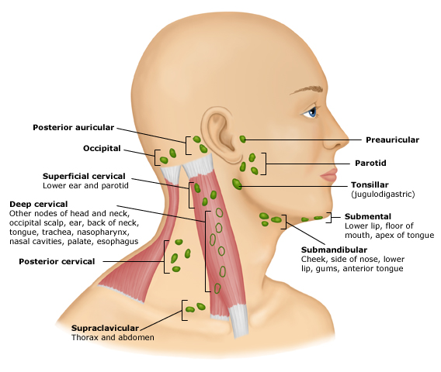13

3. The Parotid Gland:
First inspect the parotid gland externally, comparing its size and contour with the opposite side. In the presence of parotid swelling, note whether it involves the entire gland or some part of it. Perform this palpation while standing behind the patient and examining both sides at the same time. The majority of parotid masses occur in the tail - i.e. behind the angle of the mandible. Inspect the duct that opens at its papilla opposite the second upper molar tooth. Observe saliva coming from the papilla by "milking" the gland, compressing it against the angle of the mandible externally. Saliva should be clear. White discharge from the duct indicates a diseased gland. Deep lobe parotid tumours may cause medial displacement of the pharyngeal wall (parapharyngeal swelling) - the tonsil is pushed medially rather than downward and medially as with a quinsy. The soft palate is swollen and palpably firm. Don’t forget to test the facial nerve as it branches in the parotid gland.
4. The Submandibular Gland:
Similarly inspect the submandibular gland and compared it to the opposite side. Standing in front of the patient, palpate each side bimanually. For the right gland, palpate the gland with your left hand while inserting a gloved right index finger into the floor of mouth on that side. Ballot the gland between the fingers of each hand and palpate along the line of the duct for stones. Change hands for the other side. Inspect the papillae opening on either side at the base of the frenulum and milk saliva from the gland, again noting any discoloration of the saliva.

5. Thyroid:
First inspect the thyroid externally, noting whether there is either whole gland swelling or an asymmetrical swelling. See if it moves with swallowing. Then palpate the thyroid gland by standing behind the patient, noting that a normal thyroid is not palpated easily. Feel in the region of the isthmus and then each lobe using your right hand to feel the left lobe, and your left hand to feel the right. Asking the patient to swallow may allow the opportunity to feel a nodule elevate beneath your fingers. To complete the assessment of the thyroid, note changes that could indicate hyper or hypothyroidism, e.g. hair, nails, skin, eyes, tremor, reflexes, etc.

Exercise: Examine the neck of one of your colleagues. You should be able to identify at least one lymph node in the neck.

D. Clinical Examination of the Larynx

This is a difficult area to examine without the right instrumentation. However by the bedside you can:

- Airway:
Listen to the patient breathing at rest and during exertion. Also look for signs of airway distress such as talking in short sentences, tracheal tug or tachypnea with mild exertion.

To test for stridor ask the patient to open their mouth widely and take a deep breath in and then force expiration. This will make any stridor obvious.

- Voice assessment:
Ask the patient to say their name and address and listen to the voice for: pitch, quality, hoarseness, strain and volume. Does the voice sound normal? Does it sound like a “hot potato” (supraglottic swelling), hoarse, or whispery (vocal cord palsy)?

Next ask patient to take a deep breath and count from 1 to 20 in one breath. This is the expiratory time and is shortened in patients with vocal cord palsy. Normal patients can count to at least 15 in one breath.

Lastly ask the patient to shout “Taxi” and listen to the volume and quality.

3. Nasoendoscopy:
This is where a flexible nasoendoscopy is passed down to the level of the larynx through the nose. Along the way other structures are observed, specifically the posterior nasal space, base of tongue, vallecula and epiglottis. The patient is asked to blow out their nose against pinched nostrils to open up the piriform space to allow visualisation. Next the patient’s larynx is observed at rest and during phonation to look at the movement.

We can also look at swallowing function by asking the patient to swallow water or food coloured with blue dye while the nasoendoscopy is sitting just above the larynx. This is called a FESS (Functional Endoscopic Swallow Study) and is done with the Speech Pathologist.
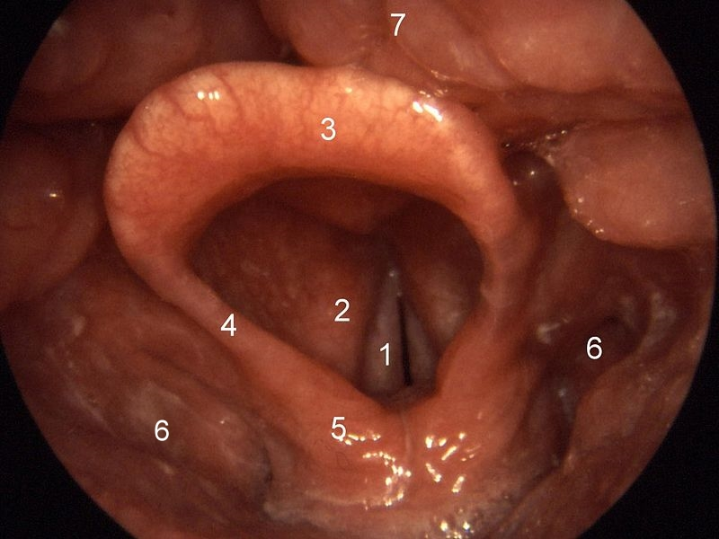
1. Vocal fold (cord)
2. Vestibular ligament/fold
3. Epiglottis
4. Aryepiglottic fold
5. Corniculate cartilage
6. Piriform sinus
7. Lingual tonsil
14

Quick ORL Quiz
For more questions see http://www.flexiblelearning.auckland.ac.nz/orl

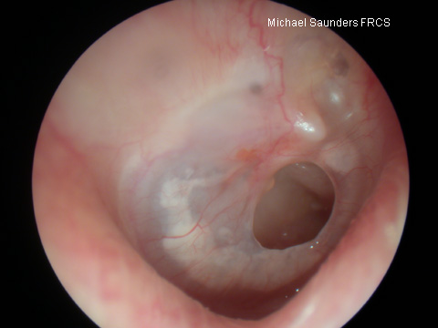

Q1:
- What is the abnormality in this picture?
- Describe it as if on the phone to an ORL reg miles away
- What advice would you give to the patient you are seeing for the 1st time in your GP/ED practice, involving daily care for this condition?

15

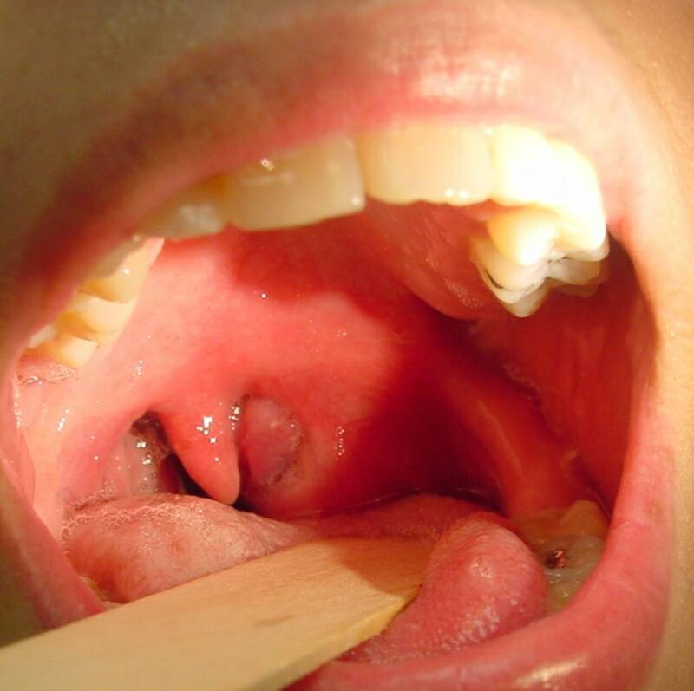

Q2:
- What is the likely diagnosis here?
- What are the typical symptoms the patient will complain about?
- What treatment is required?
- What MUST you check, prior to referring this patient to ORL for r/v?
16
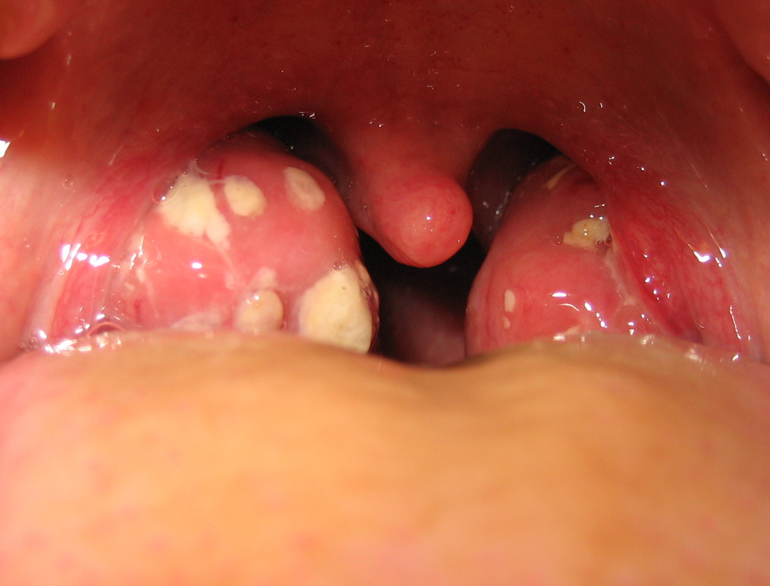
Q3
17
- What is the likely diagnosis?
- What are the pathogens likely to be responsible? Discuss ways of distinguishing between different types?
- What tests would you order in GP/ED practice?
- What treatment and what advice would you give?
- What MUST you check before d/c’ing the patient or referring to ORL?

17

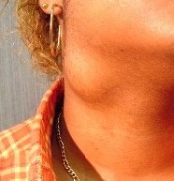
Q4:
- What history do you need to take for a patient presenting with above?
- What is your differential diagnosis – in a child? In an adult?
- What investigations would you perform in GP/ED practice?

18
COMMON + IMPORTANT ORL CONDITIONS TO SEE

- Otitis Externa
- Otitis Media with Effusion
- Chronic Otitis Media
- Cholesteatoma
- Profound Deafness
- Benign Positional Vertigo
- Meniere’s Disease
- Conductive Hearing Loss
- Sensorineural Deafness
- Nasal Fracture
- Nasal Septal Deviation
- Allergic Rhinitis
- Nasal Polyps
- Chronic Sinusitis
- Epistaxis
- Tonsillitis & Quinsy
- Salivary Calculus
- Neck Cyst
- Vocal cord Palsy
- Laryngeal Pathology
- Thyroid Nodule
- Oral Cancer
- Stridor
- Dysphagia
- Compressive Goitre
- Metastatic Nodes
- Parotid Tumour

CORE and Supplementary ORL Study QUESTIONS

Ear Disease including Hearing Loss and Otitis Media
- Draw the key landmarks of a normal left tympanic membrane.
- Describe the two key tuning fork tests and their limitations
- How do you differentiate between conductive and sensorineural hearing loss?
- List the 3 major pathogens to be found in acute otitis media (AOM) in children. Which antibiotic (dose and duration of treatment) is likely to be your 1st choice? Which children should be treated?
- Describe three key signs of otitis media with effusion
- What is pneumatic otoscopy? How it may help differentiate between the normal tympanic membrane and otitis media with effusion?
- Name at least 4 anatomical sites that can cause referred pain to the ear.
- How long after a diagnosis of AOM should you see a child for a review?

Pharyngitis/Tonsillitis
- What clinical signs reliably distinguish viral tonsillitis/pharyngitis from bacterial?
- What is the peak age range for “strep throat” and what % of sore throats culture strep in this age group?
- What advice must you give so that a prescription for penicillin is taken correctly?
- Duration of treatment for a strep throat in a child? In an adult?
- Does a full course of treatment for strep eradicate the risk of rheumatic fever? Glomerulonephritis?
- List six causes of throat pain other than tonsillitis/pharyngitis.
- List 3 conditions causing sore throat that may necessitate urgent hospital referral.
- List the indications for referral for consideration of tonsillectomy?
9. Hypertrophy of which ENT structures can cause snoring and OSA?

Rhinosinusitis and URTI

- List the key symptoms and signs that can reliably differentiate between viral and bacterial causation in an Upper Respiratory Tract Infection?
- List the 3 most common bacterial pathogens causing sinusitis?
- Name the antibiotic of choice for acute maxillary sinusitis, its duration of use and three possible side effects.

Dizziness
- Define synonyms for ‘dizziness’: vertigo, lightheadedness and syncope.
- Why is the onset of the very first episode particularly significant?
- What key signs help distinguish central from peripheral causes of “dizziness”?

References
- http://www.umm.edu/patiented/articles/otoscope_examination_000419.htm
- Wikicommons. Dr Emad Kayyam. www.scribed.com/dre,ad_kayyam6629
- http://www.audiologyonline.com/articles/article_detail.asp?article_id=1871
- www.anatomybox.com/bells-palsy
- www.medicfrom.com/publicpress/symptoms/references-h.html
- www.medical-dictionary.thefreedictionary.com/weber+test
- www.faculty.irsc.edu/faculty/jschwartz/AP1%20Ch15.htm
- ABC of ear, nose, throat surgery. 6th ed. Harold Ludman and Patrick J Bradley
- http://www.pedsent.com/problems/aud_audiogram.htm
- Baylor College of Medicine. www.bcm.edu/oto/imdex/cfm?pmid=15475
- Netter’s Atlas of Human Anatomy
- Netter’s Atlas of Human Anatomy
- uptodate.com
- Dr. Ghorayeb. www.ghorayeb.com/files
- www.dochazenfield.com/images/necklump.jpg
- Dr. Ghorayeb. www.ghorayeb.com/files
- http://upload.wikimedia.org/wikipedia/commons/9/95/Tonsillitis.jpg
- Dr. Ghorayeb. www.ghorayeb.com/files

