General Comments

Original link provided to welcome page – was hard to find the modules. Was looking on the left, but found it eventually at top right looking rather camouflaged. Maybe change the text colour, or make it larger or bolder or something.

Menu on left too plain-text like, doesn’t look stylish/professional enough. Formatting of heading, sub-heading and links = too different.
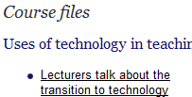

Epigeum logo above welcome box could be linked to somewhere so people can find out what Epigeum is.
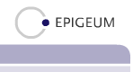

This heading is easy to overlook. I didn’t see it for a long time.
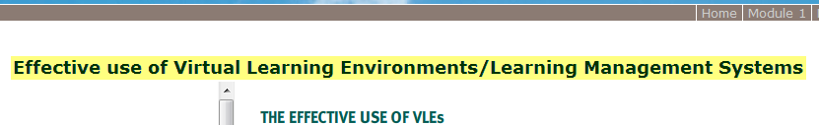
I suggest removing it and replacing with a new one on left as shown, as at first glance I didn’t realise the menu on the left was specific to the module, I thought it might be the menu for the whole thing, this may be clearer (using matching fonts of course):
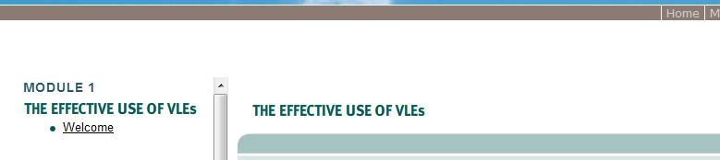

Criteria for evaluation - Module 1

Presentation and layout

Branding
- Is there obvious branding?
- How can this be achieved for elearning group in CAD?

Add logo next to Epigeum’s on welcome screen for CAD/eLearning – for all modules.
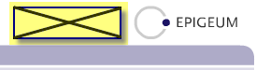

Welcome message
- Does this make sense?
- Would you change it in any way?

I don’t see the help icon anywhere. Will it only appear if I need to install something?
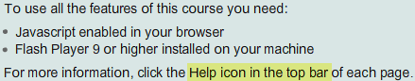

Learning outcomes/objectives/goals
- Are these clearly stated, challenging yet achievable (realistic)?
- Are the objectives followed through in the content?
- Are these linked to the assessment strategies?
- How realistic and useful are the time estimates on every page?
This is a weird movement of text, can it be fixed?

The “2.0” part moves from the second line to the end of the first line when you hover over the link.

Multimedia
- Are the multimedia elements (graphics, audio, video, Flash objects) of acceptable quality?
- Are these accessible?

Navigation
- Is the navigational structure well defined?
- Is there a site map?
- Are users clear of their current location within the module with regards to the rest of the content?
- Is there information on how the system works?
Cannot access the next page/section of the module from the end of the current screen. This was very frustrating as I could even match up the screen I was on to the item in the left menu, because I had to be looking at the right heading i.e.
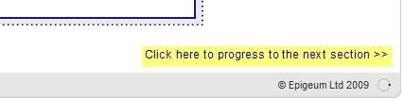

Somehow highlight the topic/page you are currently viewing in the left menu i.e.:
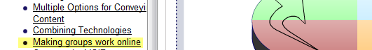

Double scroll bars on the right is a bit of a pain, clunky-feeling, can anything be done about that?


This image moves and it looks like it is already loading, as if I should wait for something:
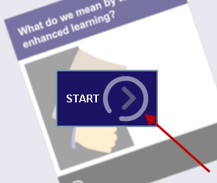

I would assume this Email button is like a submit my answer by email button (especially cause it asks me to enter my name first), therefore I would be scared to touch it, and therefore would not want to fill in the form, how is it going to help me? (In module 2, the circle doesn’t move).
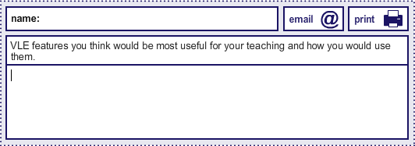

Can we view a correct answer for this exercise?
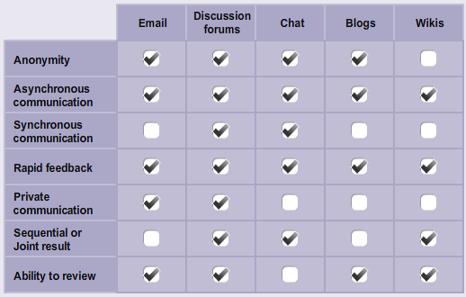

Geocaching – yay, my favourite pastime!!
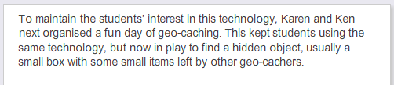

When you click start, could one page already be exposed, rather than starting with this blank screen, and then having to go back and read the instructions if you haven’t already.
Current start position:
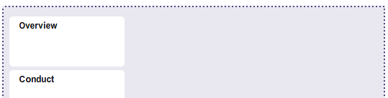
Proposed start position:
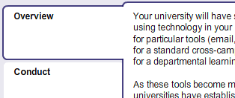

Can you hyperlink these web addresses, so people can easily see some of these books are available online, without having to actually read the text?


At the bottom of the course quiz answer page, have a link that says “Try quiz again”
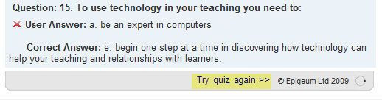
And maybe put a close button at the bottom of the answer page too (as it opens in a new window).

Criteria for evaluation - Module 2

Presentation and layout
Could this image have its colour corrected at all?


Pop up description goes off the bottom of the page:
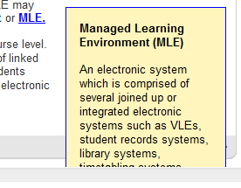

Finally found the links. Can these be put onto the bottom of the content screen? I went through the whole module 1 never seeing these links!
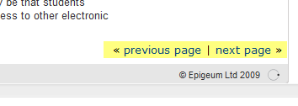
Oh no! I just clicked on one of these links and it takes you to the next module, not the next page within your current module, confusing!! We definitely need a link to take you to the next page within the current module.

Branding
- Is there obvious branding?
- How can this be achieved for elearning group in CAD?

Welcome message
- Does this make sense?
- Would you change it in any way?

Spell out the full words for “VLE’s” in both these places.
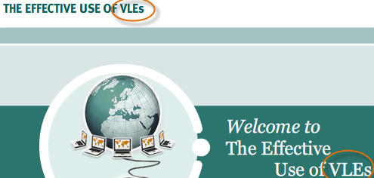

Learning outcomes/objectives/goals
- Are these clearly stated, challenging yet achievable (realistic)?
- Are the objectives followed through in the content?
- Are these linked to the assessment strategies?
- How realistic and useful are the time estimates on every page?

Multimedia
- Are the multimedia elements (graphics, audio, video, Flash objects) of acceptable quality?
- Are these accessible?
Should you have a print option where you have an email option? I’m wondering if you should be actively promoting a paper-free learning environment but not specifically offering a print button where you could just have the email option?? If they really want to print they can just use the print option of the browser, can’t they?


The audio for several if not all of these characters are quite badly distorted:
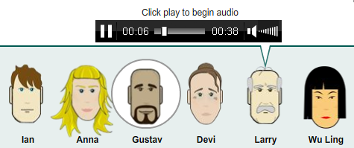

Navigation
- Is the navigational structure well defined?
- Is there a site map?
- Are users clear of their current location within the module with regards to the rest of the content?
- Is there information on how the system works?
Clicking one of these tick boxes disables your scroll lock on the page, so you can’t scroll up to reread the character descriptions again to continue with your answers, unless you click somewhere else on the page first.
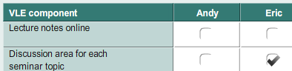

Also, another example of the same thing, I clicked on the start button for this exercise, got this screen, and then wanted to scroll up to see the rest of the exercise window, but couldn’t, then had to click elsewhere on the screen to activate my mouse’s scroll again:
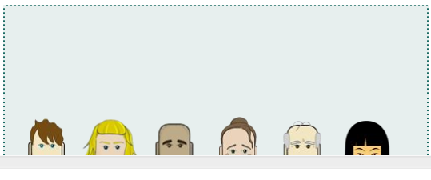

Criteria for evaluation - Module 3

Presentation and layout
Photograph not good enough quality:


Typo:
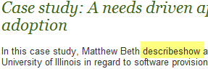

There is no VLE on this page to hover over/click on for a description, so this pop-up is not very helpful, maybe it could be rephrased?
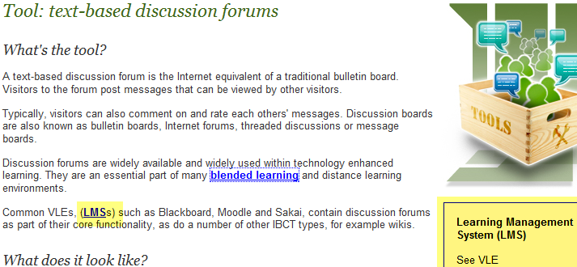

Can this start with one of the info bubbles displaying (instead of being blank):
Current display at start:
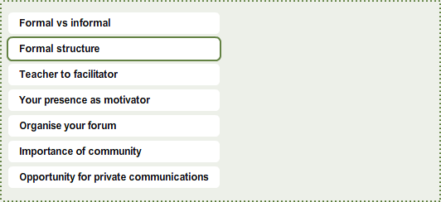
Proposed display at start:
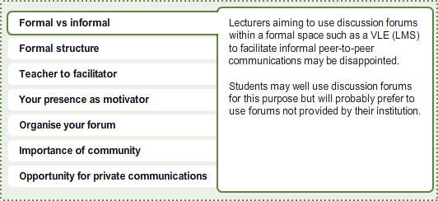

Pop up box is hanging off the page (An introduction to knowledge building using IBCTs) and therefore not completely legible:
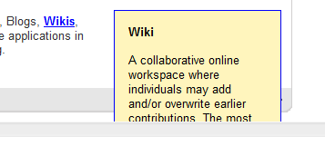

Another pop-up hanging off the bottom of the page (Tool: Collaborative workspaces):
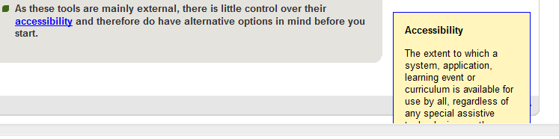

Label is very hard to read on this video (Tool: Microblogging).:


This looks like a mistake, this is the starting view of an exercise on the Institutional contexts page:
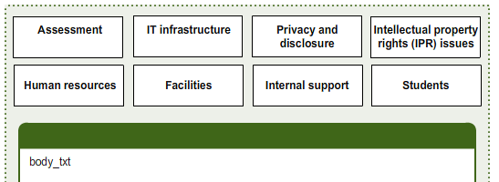

There is a green box appearing on the page of step 1 & step 2 for the exercise box on page Selecting an IBCT. It only appears after you have used the scroll bar on step 3.
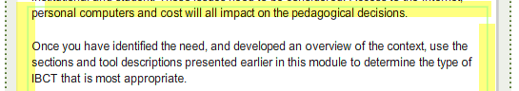

Popups don’t pop up on this page, the information appears different, and not highlighted at all:
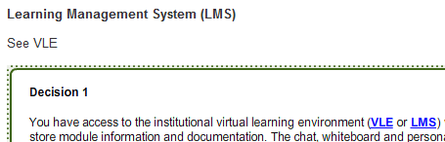

Pop up text appears too large on resources page:
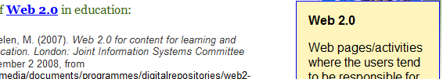

Offer an email option, not a print option for course quiz answers page:
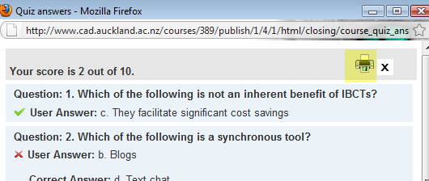

Branding
- Is there obvious branding?
- How can this be achieved for elearning group in CAD?

Welcome message
- Does this make sense?
- Would you change it in any way?

Learning outcomes/objectives/goals
- Are these clearly stated, challenging yet achievable (realistic)?
- Are the objectives followed through in the content?
- Are these linked to the assessment strategies?
- How realistic and useful are the time estimates on every page?
I think this should say personal website, not URL/address (author profiles).

Multimedia
- Are the multimedia elements (graphics, audio, video, Flash objects) of acceptable quality?
- Are these accessible?

Navigation
- Is the navigational structure well defined?
- Is there a site map?
- Are users clear of their current location within the module with regards to the rest of the content?
- Is there information on how the system works?

Criteria for evaluation - Module 4

Presentation and layout

Branding
- Is there obvious branding?
- How can this be achieved for elearning group in CAD?

Welcome message
- Does this make sense?
- Would you change it in any way?

Learning outcomes/objectives/goals
- Are these clearly stated, challenging yet achievable (realistic)?
- Are the objectives followed through in the content?
- Are these linked to the assessment strategies?
- How realistic and useful are the time estimates on every page?

Multimedia
- Are the multimedia elements (graphics, audio, video, Flash objects) of acceptable quality?
- Are these accessible?

Navigation
- Is the navigational structure well defined?
- Is there a site map?
- Are users clear of their current location within the module with regards to the rest of the content?
- Is there information on how the system works?

Criteria for evaluation - Module 5

Presentation and layout

Branding
- Is there obvious branding?
- How can this be achieved for elearning group in CAD?

Welcome message
- Does this make sense?
- Would you change it in any way?

Learning outcomes/objectives/goals
- Are these clearly stated, challenging yet achievable (realistic)?
- Are the objectives followed through in the content?
- Are these linked to the assessment strategies?
- How realistic and useful are the time estimates on every page?

Multimedia
- Are the multimedia elements (graphics, audio, video, Flash objects) of acceptable quality?
- Are these accessible?

Navigation
- Is the navigational structure well defined?
- Is there a site map?
- Are users clear of their current location within the module with regards to the rest of the content?
- Is there information on how the system works?

Criteria for evaluation - Module 6

Presentation and layout

Branding
- Is there obvious branding?
- How can this be achieved for elearning group in CAD?

Welcome message
- Does this make sense?
- Would you change it in any way?

Learning outcomes/objectives/goals
- Are these clearly stated, challenging yet achievable (realistic)?
- Are the objectives followed through in the content?
- Are these linked to the assessment strategies?
- How realistic and useful are the time estimates on every page?

Multimedia
- Are the multimedia elements (graphics, audio, video, Flash objects) of acceptable quality?
- Are these accessible?

Navigation
- Is the navigational structure well defined?
- Is there a site map?
- Are users clear of their current location within the module with regards to the rest of the content?
- Is there information on how the system works?

Criteria for evaluation - Module 7

Presentation and layout

Branding
- Is there obvious branding?
- How can this be achieved for elearning group in CAD?

Welcome message
- Does this make sense?
- Would you change it in any way?

Learning outcomes/objectives/goals
- Are these clearly stated, challenging yet achievable (realistic)?
- Are the objectives followed through in the content?
- Are these linked to the assessment strategies?
- How realistic and useful are the time estimates on every page?

Multimedia
- Are the multimedia elements (graphics, audio, video, Flash objects) of acceptable quality?
- Are these accessible?

Navigation
- Is the navigational structure well defined?
- Is there a site map?
- Are users clear of their current location within the module with regards to the rest of the content?
- Is there information on how the system works?

